Code for count the words
Count.html
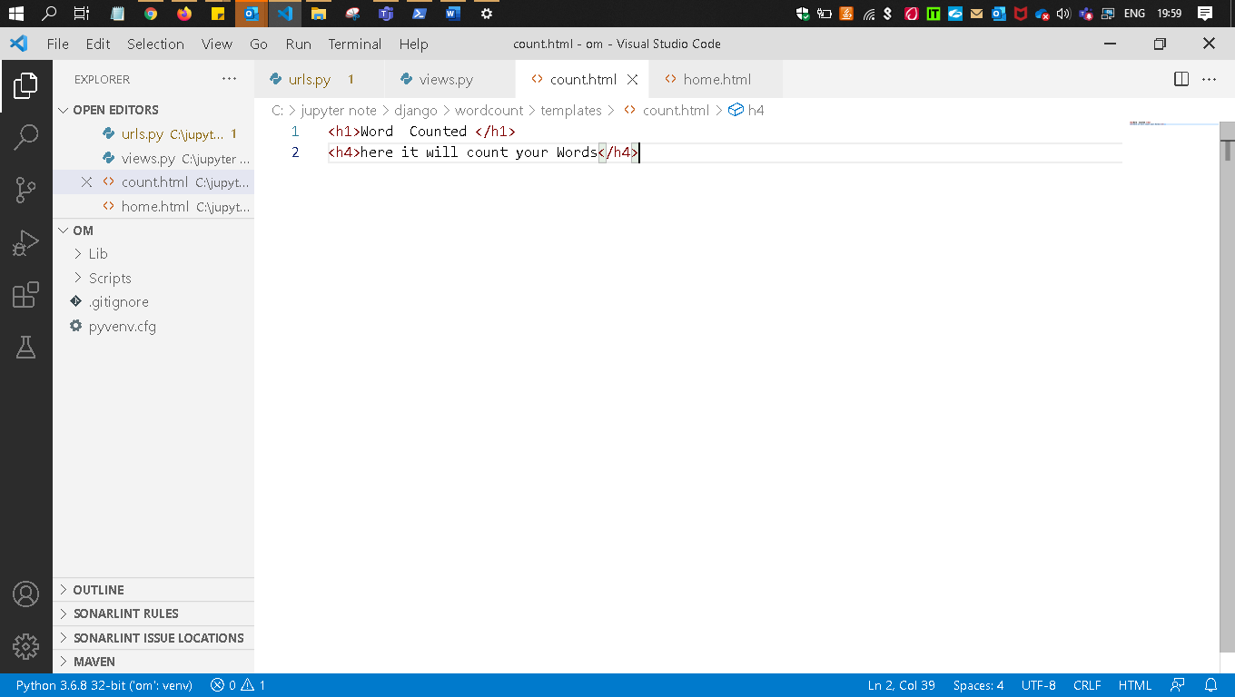
Views.py
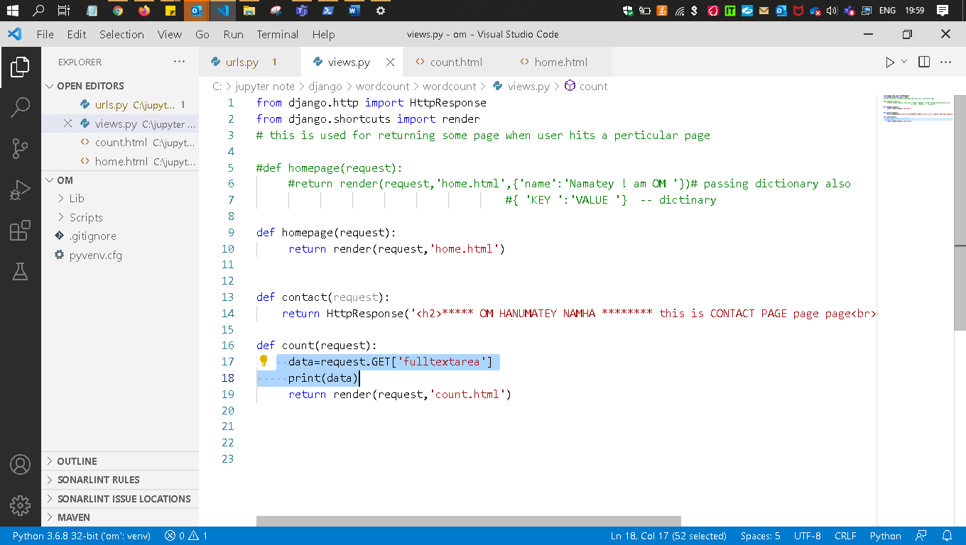

URL.PY
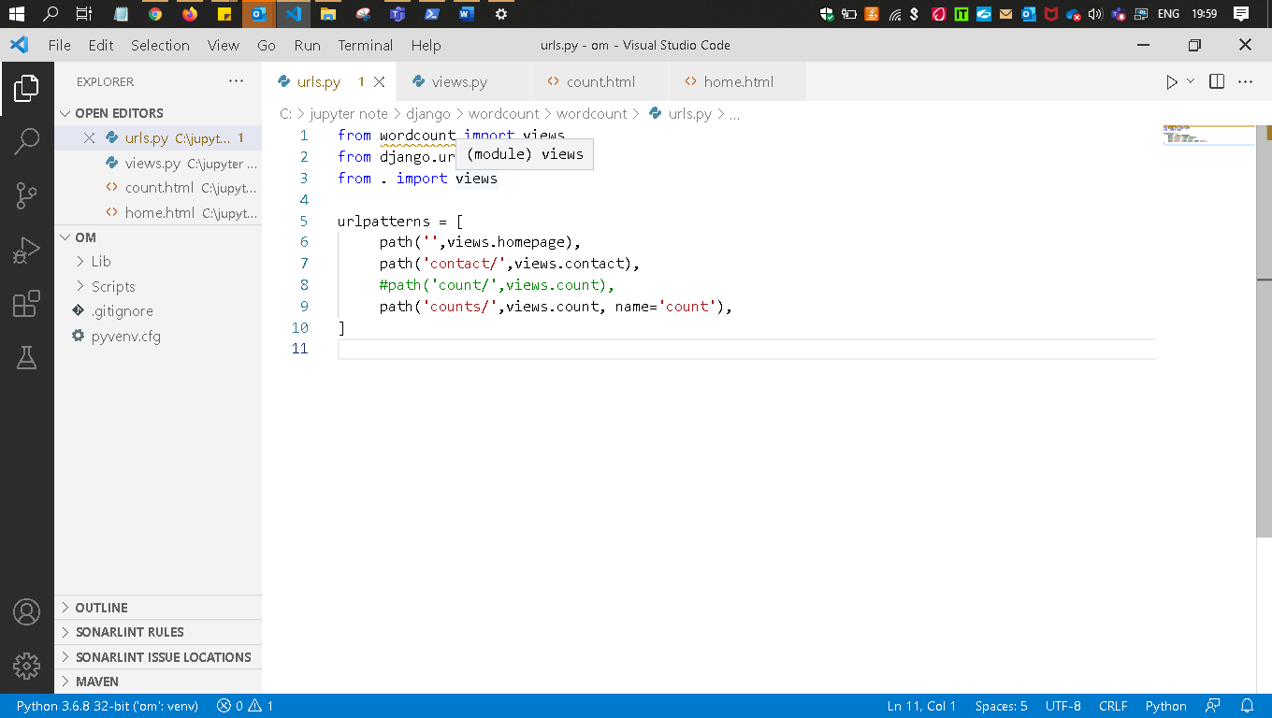
Re-run the server
Seethe word in highlighted
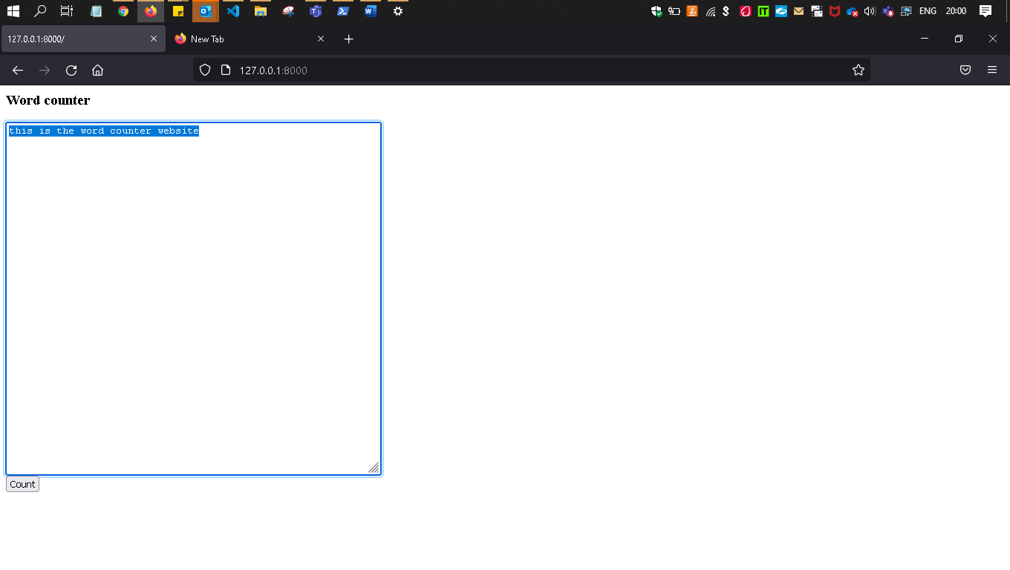
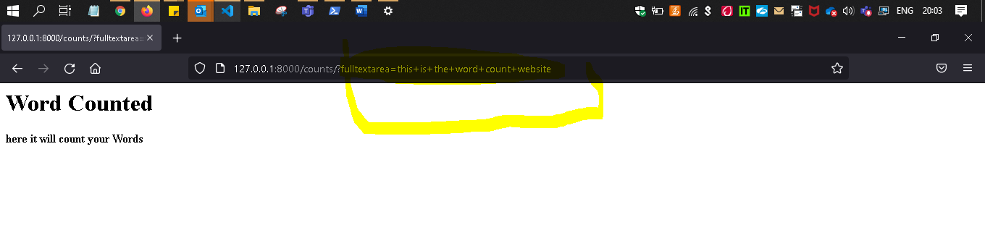
After submitted the form
Ques - Now pass the data from home.html to the count.html
Sol - only change this
View.py
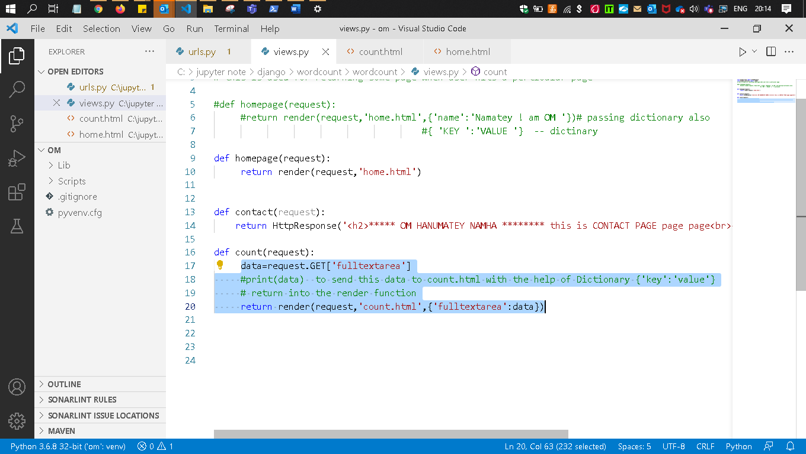
Count.html
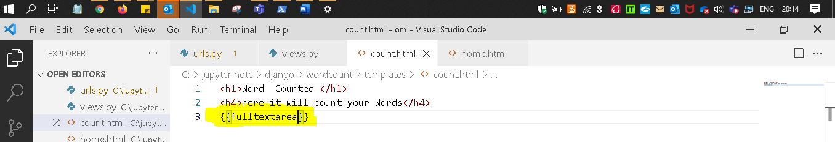
Re-run the server
This is the login.html which is running the home page
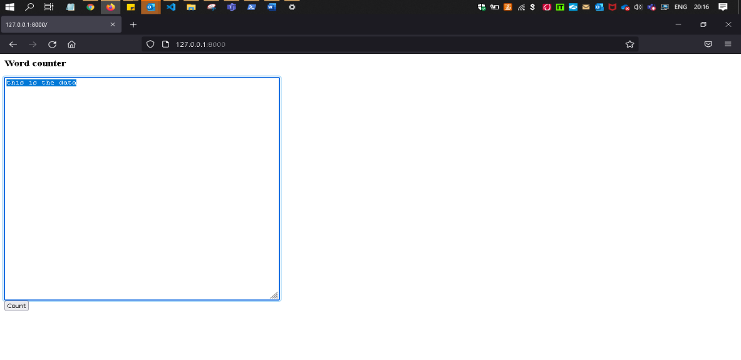

Count.html
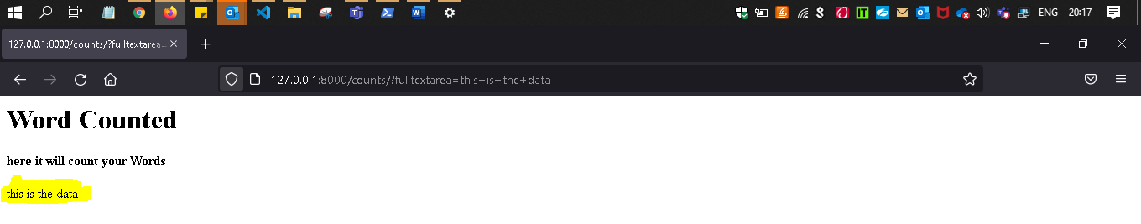

Quest - )Now I want to count this highlighted no of words present in it.
Convert this string into List than we can count that and then apply the split()

Split()- split the word after getting space 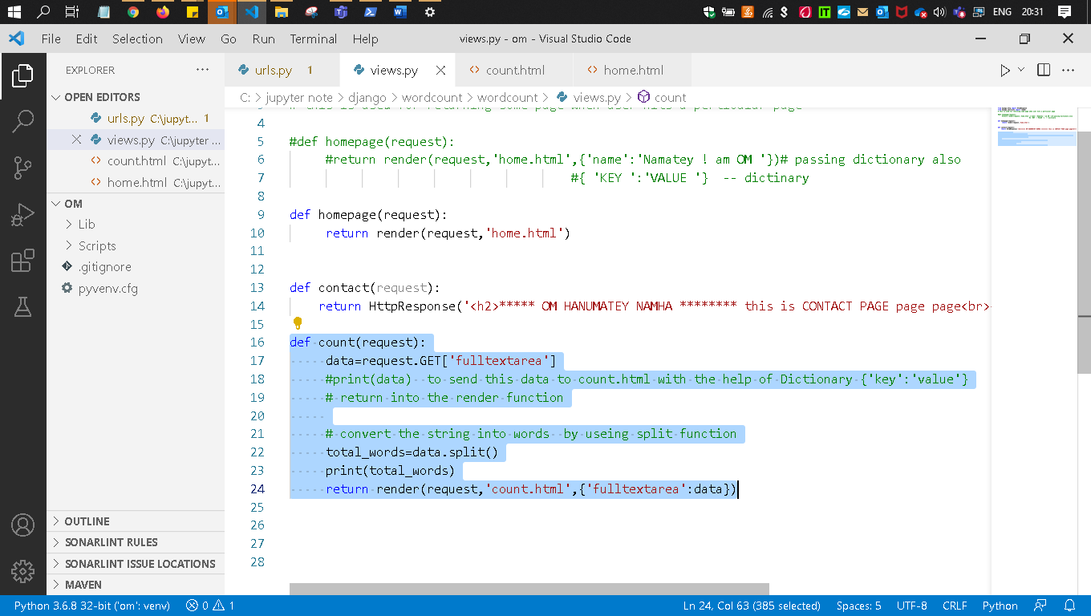

Re run server

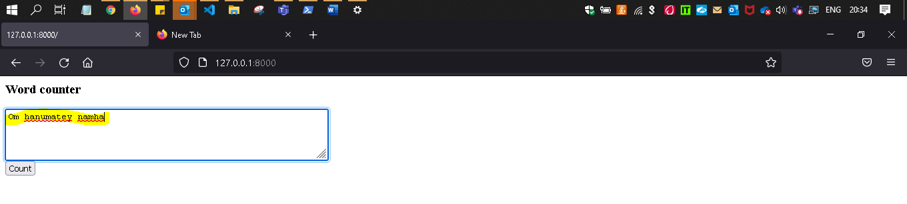

See it splitted
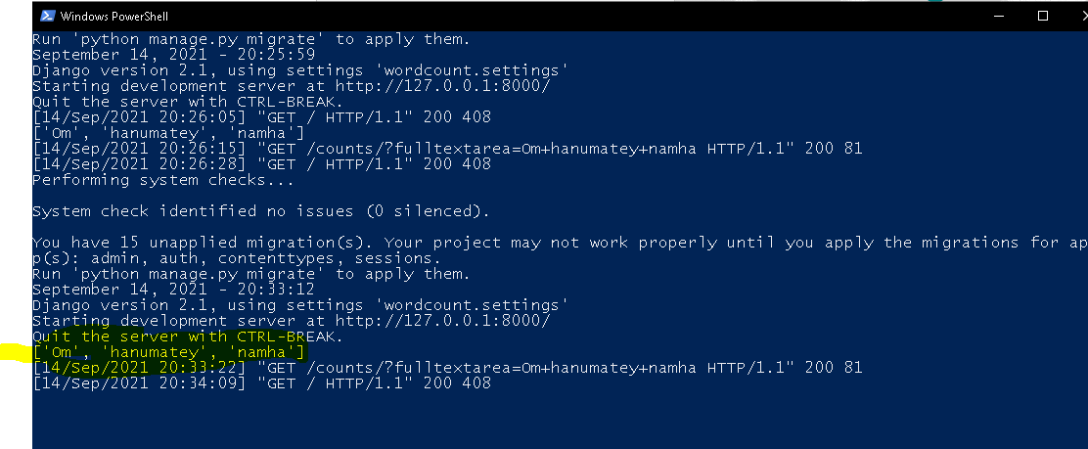
Now Count this words
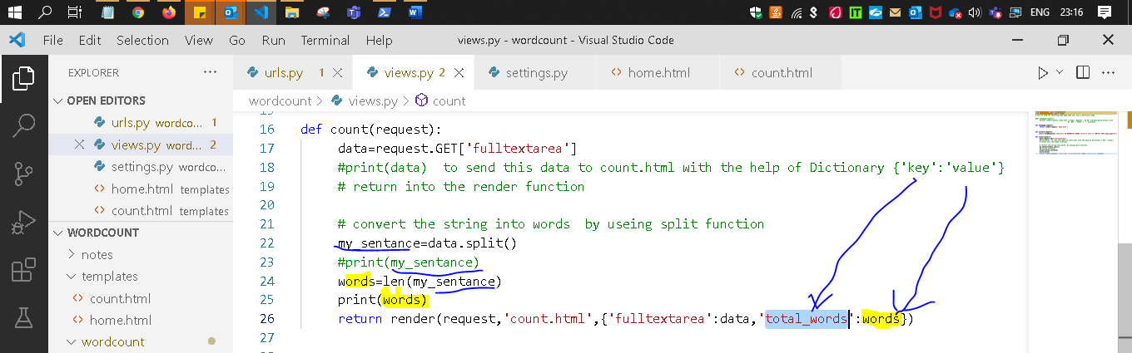
home.html
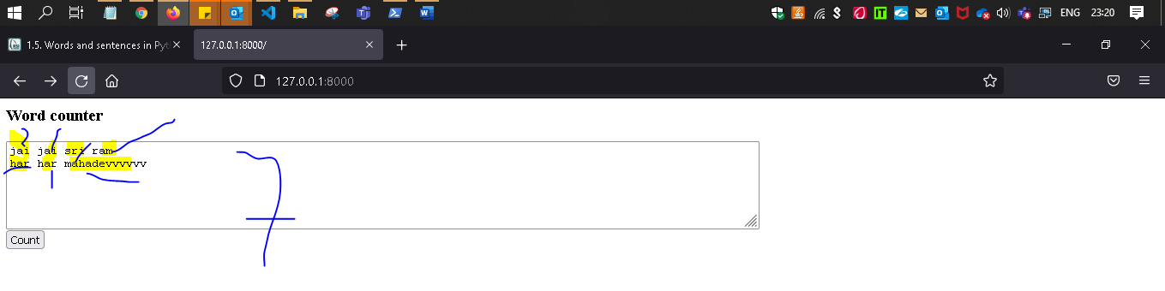
Count.html
